HHS CDC HR BizFlow System

Deployment

Document Control Information

Document Information

|  |  |
| --- | --- |
| Document Identification | HHS CDC BizFlow HR System Deployment.docx |
| Document Name | Deployment |
| Project Name | HHS CDC BizFlow HR System |
| Client | Centers for Medicare and Medicaid |
| Document Author | Taeho Lee |
| Document Version | 1.0.0 |
| Document Status | Draft |
| Date Released | 14-Nov-2018 |
| Business Specifications Requirement Document ID |  |
| Functional Specification ID |  |

Document Edit History

| Version | Date | Additions/Modifications | Prepared/Revised by |
| --- | --- | --- | --- |
| 1.0 | 11/14/2018 | Initial Draft | Taeho Lee |
| 1.1 | 11/15/2018 | Github, ERA, BIX sections added | Taeho Lee |

Document Review/Approval History

| Date | Name | Organization/Title | Comments |
| --- | --- | --- | --- |
|  |  |  |  |
|  |  |  |  |
|  |  |  |  |
|  |  |  |  |
|  |  |  |  |

Distribution of Final Document

The following people are designated recipients of the final version of this document:

| Name | Organization/Title |
| --- | --- |
| <Name> | <Organization/Title> |
|  |  |

Table of contents

1 Introduction 4

2 Required system version information 5

3 Required software 6

4 Methods of deployment file delivery 8

4.1 Development repository in GitHub 8

5 Github Development directory structure 10

5.1 database Directory contents 10

5.2 deploy directory contents 11

5.3 era directory contents 11

5.4 java directory contents 11

5.5 process directory contents 12

5.6 report directory contents 12

5.7 wm-project directory contents 12

6 Deployment Steps 14

6.1 Database Deployment 14

6.2 Create database schema and user 14

6.3 Grant permission required for program object creation 14

6.4 Create DB SEQUENCE 15

6.5 Create core tables for business data model 15

6.6 Create tables for business data model 15

6.7 Create views for business data model 15

6.8 Create function objects 16

6.9 Create function objects 16

6.10 Grant permission to the business data mode objects created 16

6.11 Create trigger objects 16

6.12 Grant permission to the functions and stored procedure created 17

6.13 Insert seed data (a.k.a. day-zero data) 17

6.14 BIX deployment 17

6.15 Configure BizFlow Process Studio 19

6.16 Report Deployment 30

6.17 BizFlow Rule Microservice Deployment 32

6.17.1 How to check if BizFlow Rule Microservice already installed 32

6.17.2 How to check if BizFlow Rule Microservice already installed 33

6.18 UI Module Packaging 34

6.18.1 Pre-requisite on DEV Server 34

6.18.2 Packaging Steps 34

6.19 Web Application (UI Module) Deployment 35

7 BizFlow Global Variable Configuration 37

8 BizFlow ERA Configuration 39

8.1 CDC – CapHR – JR ERA service 39

8.2 CDC – CapHR – PAR ERA service 49

# Introduction

This document describes how to deploy the HHS CDC BizFlow HR system. It is assumed that there are 3 environments, DEV, QA, and PROD. The instruction for deployment for each environment will be the same except for configuration. Configuration should be done specifically for each target environment.

# Required system version information

1. BizFlow: BizFlow Server version 12.4.x
2. Database: Oracle 12c
3. Web Server: Tomcat 7 64bit
4. Java: JDK 7.x as of today (11/14/2018)

# Required software

Install following software on your HHS Laptop. These tools are required for HHS Production deployment.

1. Git
   1. Git – Download from following URL

https://git-scm.com/download/win

* 1. You can download setup module or portable module.
  2. Setup module requires insallation, but portable module doesn’t.
  3. After installation is completed (or extraction), execute following command from command prompt.

git clone <https://github.com/HHS/CDC-BizFlow.git>

* 1. You can find CDC-BizFlow folder. And this folder will be referenced as [git/CDC-BizFlow].

1. BizFlow Process Stuiod (BPS)
   1. Installation is required.
   2. Download from following URL.

<http://cms.bizflow.com/bizflow/setup/BizFlow_Process_Studio_12.4.zip>

* 1. Install BPS. Refer 4.1
  2. Check whether you can connect to BizFlow on HHS Production environment before deployment. Refer 3.2

1. BizFlow Reporting Tool
   1. Download from following URL or alternatively you can download from download.bizflow.com.

[http://cms.bizflow.com/bizflow/setup/BizFlowReporting.zip](http://cms.bizflow.com/bizflow/setup/BizFlow_Advanced_Reporting_12.4.zip)

* 1. Extract BizFlowReportin.zip file.
  2. You can find BizFlowReporting folder. This folder will be referenced as [BizFlowReporting].

1. Winscp.exe or FTP client
   1. Deployment package should be uploaded to HHS Production environment.
   2. Check if you can connect to HHS Production environment before deployment.
2. Putty
   1. Download from following URL

<https://www.putty.org>

* 1. Installation is not required but just extract zip file.
  2. Check whether you can connect to HHS Production environment before deployment.

# Methods of deployment file delivery

## Development repository in GitHub

1. Log in to GitHub for HHS (https://github.com/HHS).
2. On the dashboard, select context dropdown to “HHS”.
3. On the Repositories pain, search for “BizFlow”, and select “HHS/CDC-BizFlow”.

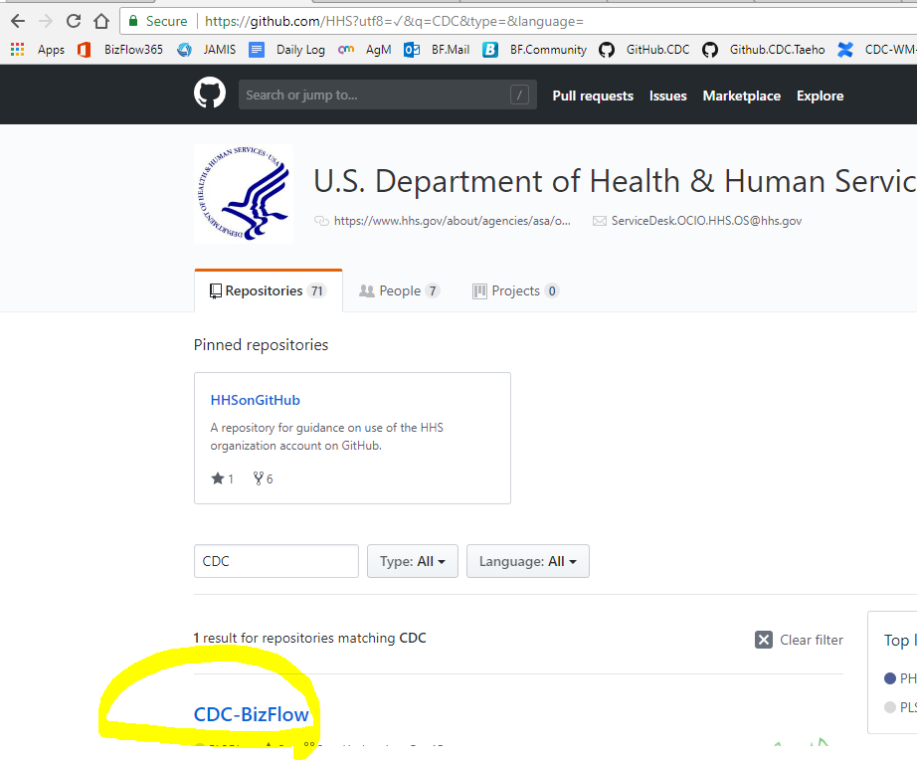

1. Verify the URL and repository name.
2. Click “Clone or download” button. If you intend to set up local git repository and continue to use it in the future, clone the repository using SSH or HTTPS option. If you want to download the entire repository for each build/deploy, select “Download ZIP” option.
   1. For clone, from your HHS Laptop, under [git/CDS-BizFlow] folder, execute following command from command prompt.
      1. *git clone* [*https://github.com/HHS/CDC-BizFlow.git*](https://github.com/HHS/CDC-BizFlow.git)
   2. Above command will download latest codebase from github.
3. For downloading production release package only, you can find it under CDC-BizFlow/release directory in the Github repository. Please download **releaes1.0.zip** file

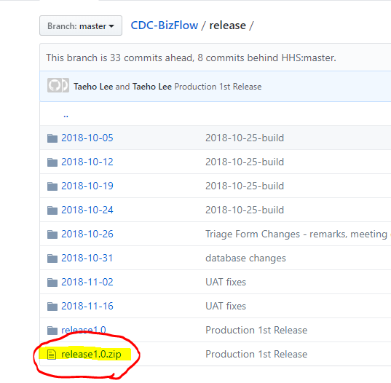

# Github Development directory structure

The following directory capture will be delivered as part of the release of the system.

* CDC-BizFlow/database
  + Database script files to create DB objects and uploading lookup records
* CDC-BizFlow/deploy
  + Deployment script files
* CDC-BizFlow/era
  + ERA queries
* CDC-BizFlow/java/bizflowrule
  + BizFlow Micro Rule Service
* CDC-BizFlow/process
  + BIX export file having process definitions, application definitions, user groups, menus, and BizCoves.
* CDC-BizFlow/release
  + Released packages. You can download release1.x.zip file for production deployment.
* CDC-BizFlow/report
  + JasperReport export file.
* CDC-BizFlow/ui/webmaker
  + WebMaker export files
* CDC-BizFlow/webapps/bizflow/solutions/hhs/cdc
  + CDC JSP web application

## database Directory contents

This directory contains database scripts (.sql files) to create database schema, users, and other objects, which includes the definition for tables, stored procedures, functions, triggers, sequence.

The DBA will execute the database scripts in Oracle database client (e.g. SQLPlus, SQL Developer, etc.) in the designated order (as part of the filename) so that the database for the system can be created. You will need to run the SQL files in order.

Script file example:

* CDC_1_create_schema.sql
* CDC_2_grant_bizflow.sql
* CDC_2_grant_hhs_hr.sql
* CDC_3_sequence.sql
* CDC_4_core_tables.sql
* CDC_4_table.sql
* CDC_5_view.sql
* CDC_6_function.sql
* CDC_7_stored_procedure.sql
* CDC_8_grant_cdc_hr.sql
* CDC_9_trigger.sql
* CDC_10_grant_function_sp.sql
* CDC_101_upload_externallink.sql
* CDC_102_upload_lookups.sql

## deploy directory contents

This directory contains script to capture web runtime files, deployment scripts, etc.

It is assumed Apache ANT is available to run the runtime capture script (build.xml).

The deployment script for UI module is for Linux server environment where shell program is available.

***Notes****: Since CDC solution is running on shared environment, the shell script files may already exist for different opDivs’ project. If the case, you will need to use build.xml for CDC project.*

For example:

* build.xml
* deploy_ui.sh

## era directory contents

This directory contains SQL queries for easier copy & paste when you create an ERA service in BizFlow

For example:

* CapHR_JR.sql
  + SQL queries for initial ERA service setup to monitor CapHR to initiate new Job Openining related Triage processes.
* CapHR_PAR.sql
  + SQL queries for initial ERA service setup to monitor CapHR to initiate new Employed Named Action related Triage processes.

## java directory contents

This directory contains custom developed modules. Currently, Micro Service for Document Rule.

Notes: No need to build the java code. bizflowrule.war is already provided in the folder

For example:

* bizflowrule/out/bizflowrule.war

## process directory contents

This directory contains BizFlow Import Export file (.bix files), which contains the process definition, the application definition, user group definition, BizCove and menu design.

The system administrator will use BizFlow Process Studio in order to import the .bix file to a designated BizFlow Server environment.

BIX file example:

* CDC_EWITS2.bix

## report directory contents

This directory contains BizFlow Advanced Reporting Export file (.zip file), which contains data source, report domain definition, input control definition, and report definition.

The system administrator will use command line tool to import the report export (.zip) file to the designated BizFlow Advanced Reporting Server environment.

Report export file example:

* CDCReports.zip

## wm-project directory contents

This directory contains WebMaker project export files (.zip files), which is form design source code.

The system administrator will use WebMaker Design Studio in order to import each of the project export files, generate runtime files, then, deploy them to the designated environments. As an alternative, wm-runtime directory contains the same generated web application files, which is ready to be deployed without going through WebMaker Design Studio.

WebMaker project export file example:

* apt_atc_export.zip
* apt_general_export.zip
* apt_main_export.zip
* apt_pm_approval_export.zip
* apt_resources_export.zip
* apt_staffing_approval_export.zip
* apt_tsa_approval_export.zip
* cdc_api_export.zip
* cdc_na_atc_export.zip
* cdc_na_general_export.zip
* cdc_na_main_export.zip
* cdc_triage_general_export.zip
* cdc_triage_main_export.zip
* cla_classification_export.zip
* cla_concurrence_export.zip
* cla_general_export.zip
* cla_main_export.zip
* cla_position_export.zip
* cla_resources_export.zip
* p2w_common_export.zip
* p2w_conditions_export.zip
* p2w_general_export.zip
* p2w_main_export.zip
* p2w_position_export.zip
* p2w_resources_export.zip
* p2w_vacancy_export.zip
* p2w_validation_export.zip
* …

# Deployment Steps

## Database Deployment

A DBA should perform the following steps using Oracle database client.

## Create database schema and user

Log in to the database system as Oracle system user, and execute the following script. Before executing the SQL script, you may want to edit the password for the database user (CDCADMIN, CDCDEV, and HHS_CDC_HR) in the script. Make a note of the database user name and password for later configuration steps.

Also, make sure the target directory where the tablespace file will be generated is already created in the file system that the DBMS is installed.

For the first SQL script file, it is recommended to execute the statements within the SQL script file one by one manually and make sure that no critical error occurs. The reason is that the first script creates tablespace, datafile, user/schema, security role,etc., which are prone to error depending on the DBMS environment. If a critical error occurs (e.g. directory does not exist, disk full, etc.) you need to resolve those issues before moving to the next command. In general, you may safely ignore “object/table/view/symbol does not exist” type of error returned when executing DROP statements.

* CDC_1_create_schema.sql

It will perform the following actions.

* Define database, specifying tablespace and database file location.
* Create database users and schemas.
* Create database roles.
* Grant permissions to the database users and roles.

## Grant permission required for program object creation

Using the Oracle system user login, execute the following script. This is pre-requsite for certain functions and stored procedures defined later on, which need to access objects in BIZFLOW schema.

* CDC_2_grant_bizflow.sql
* CDC_2_grant_hhs_hr.sql

It will perform the following actions.

* CDC_2_grant_bizflow.sql
  + Grant permissions for accessing BizFlow’s core database tables to the designated database user.
* CDC_2_grant_hhs_hr.sql
  + Grant permissions for accessing HHS_HR database tables to designated role.
  + You will need to run DBA account or HHS_HR database user.

## Create DB SEQUENCE

Log in to the database system using the newly created database user account (id = HHS_CDC_HR), using the password that was set in the step 5.1.1. As the HHS_CDC_HR database user, execute the following script.

* CDC_3_sequence.sql

It will perform the following actions.

* Create sequences in HHS_CDC_HR schema.

## Create core tables for business data model

Using the HHS_CDS_HR user login, execute the following script.

* CDC_4_core_tables.sql

It will perform the following actions.

* Create core tables for CDC business data storage. The core tables are
  + *ERA_LOG_CAPHR_JR*
  + *ERA_LOG_CAPHR_LAST_RUN*
  + *ERA_LOG_CAPHR_PAR*
  + *ERROR_LOG*
  + *TBL_FORM_DTL*
  + *TBL_FORM_DTL_AUDIT*
  + *TBL_LOOKUP*
* Create stored procedures.
  + *SP_ERROR_LOG*

## Create tables for business data model

Using the HHS_CDS_HR user login, execute the following script.

* CDC_4_table.sql

It will perform the following actions.

* Create tables for CDC business data storage.
* Create sequences, constraints, and triggers associated with the tables.

## Create views for business data model

Using the HHS_CDS_HR user login, execute the following script.

* CDC_5_view.sql

It will perform the following actions.

* Create views for CDC business data storage.

*Notes: As of today, November 14, 2018, there is no VIEW created. So, you can skip this file.*

## Create function objects

Using the HHS_CDS_HR user login, execute the following script.

* CDC_6_function.sql

It will perform the following actions.

* Create databse function objects in dependency order.

## Create function objects

Using the HHS_CDS_HR user login, execute the following script.

* CDC_7_stored_procedure.sql

It will perform the following actions.

* Create databse stored procedure objects in dependency order.

## Grant permission to the business data mode objects created

Using the Oracle system user login, execute the following script.

* CDC_8_grant_cdc_hr.sql

It will perform the following actions.

* Grant permissions for accessing the newly created database objects for business data model in the previous step to the designated database roles.

## Create trigger objects

Using the HHS_CDS_HR user login, execute the following script.

* CDC_9_trigger.sql

It will perform the following actions.

* Create databse stored procedure objects in dependency order.

*Notes: As of today, November 14, 2018, this is a placeholder file. So, you can skip this file*

## Grant permission to the functions and stored procedure created

Using the Oracle system user login, execute the following script.

* CDC_10_grant_function_sp.sql

It will perform the following actions.

* Grant permissions for accessing the newly created stored procedure and function objects for program to the designated database roles.

## Insert seed data (a.k.a. day-zero data)

Using the HHS_CDC_HR user login, execute the following scripts.

* CDC_101_upload_externallink.sql
* CDC_102_upload_lookups.sql

It will perform the following actions.

* Insert the data into external URL links for the Resources tab in CDC HR web form.
* Insert the initial lookup data into TBL_LOOKUP table, which will be used as part of numerous dropdown fields.

## BIX deployment

Import BizFlow Process definitions and BizCoves

Pre-requisite

* BizFlow Server is installed and BizFlow Server is running.
* BizFlow Process Studio (BPS) is installed.
* BizFlow user with “General Administrator” and “Designer” license is created for migration.

In this instruction, a user login “import_user” is assumed to be set up with the necessary permission. In order to verify the BizFlow user with proper permission, log in to BizFlow Portal site as a system administrator, and check the Authentication configuration.

1. Log in to BizFlow Portal as a system administrator.
2. Click “ADMINISTRATION” tab on the top right corner.
3. Click Authentication on the administration page.
4. Search the user login to verify and click on the login ID found to open User Details wizard.
5. Click License tab and Authority Group tab in the wizard to verify the license assignment and Authority Group assignment.

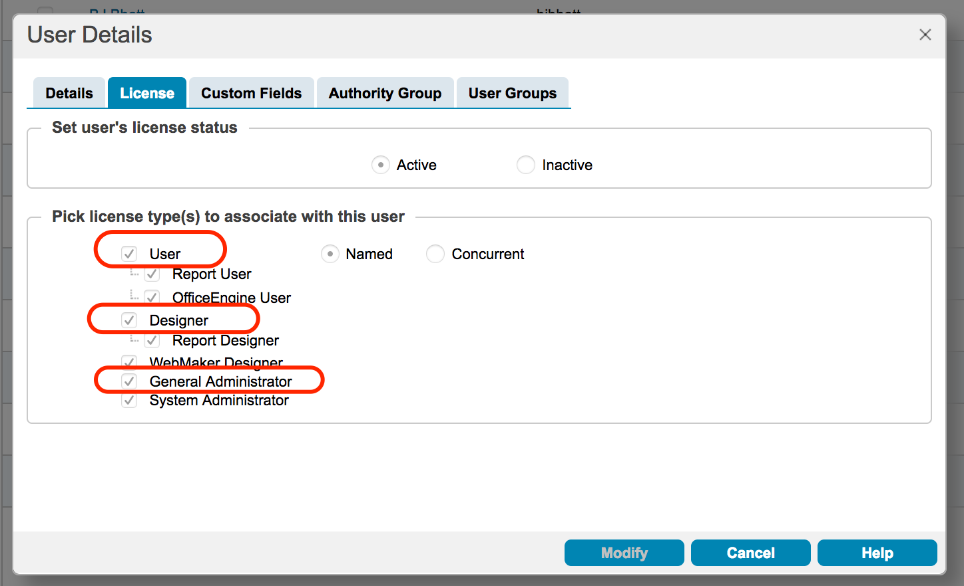

For Authority Group assignment option, it is recommended to use “Explicit”. Then, make sure explicitly select Designer and General Administrator Authority Group along with others.

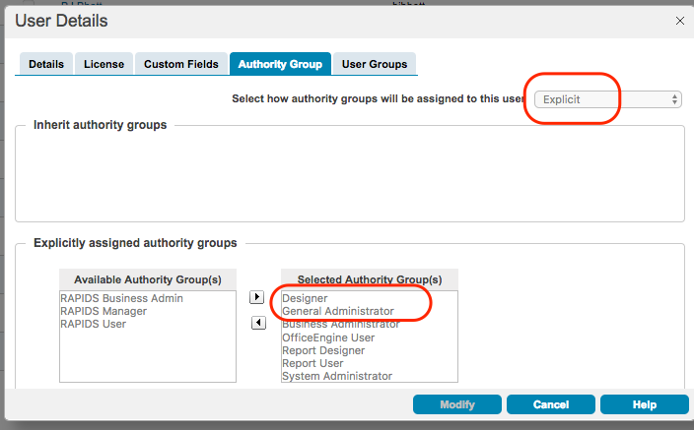

When all pre-requisite for BIX import are verified, begin the import steps.

## Configure BizFlow Process Studio

1. From your HHS Laptop, Launch “BizFlow Process Studio”
2. Click “BizFlow Server” from the File -> New from the menu of BizFlow Process Studio

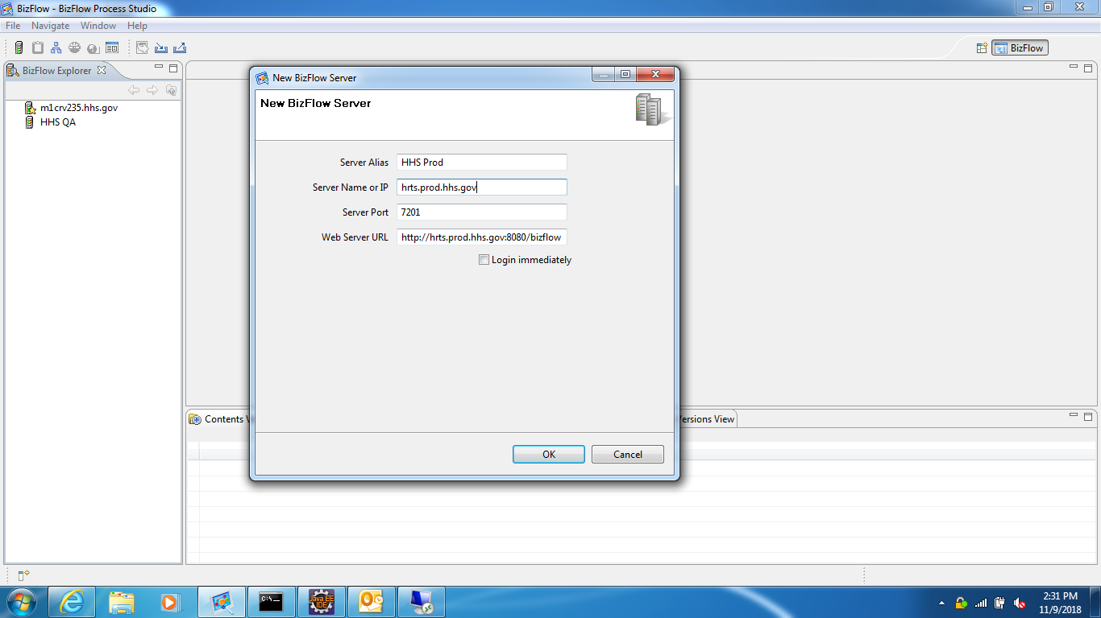

1. Enter “HHS Prod” in “Server Alias”. This will be displayed in left pang.
2. Enter “hrts.prod.hhs.gov” in “Server Name or IP”
3. Enter 7201 in “Server Port”.
4. Web Server URL will be automatically filled in. This URL should be like following.

http://hrts.prod.hhs.gov:8080/bizflow

1. Click “OK”
2. Step1 – Register BizFlow server to BPS
   1. Launch BPS and click “BizFlow Server” icon.

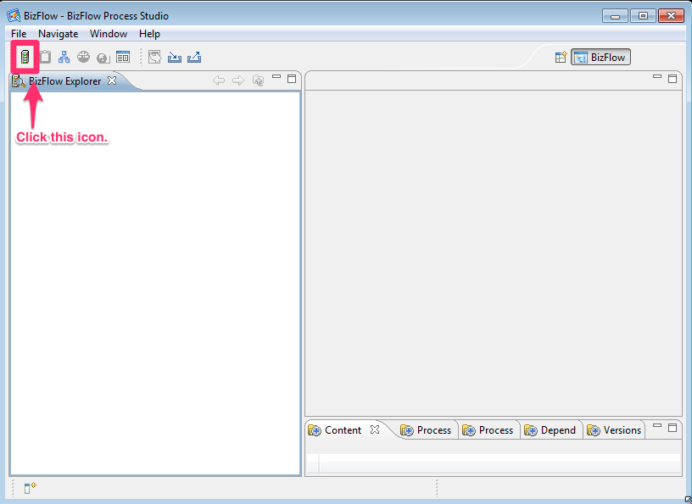

* 1. Provide Server information.

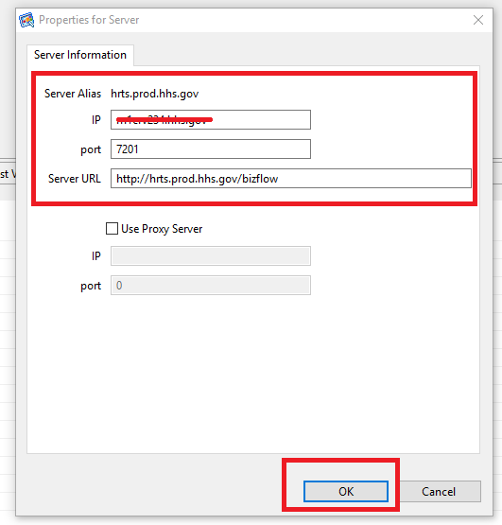

1. Step 2 - Log on to BizFlow Server.
2. This user needs to have “General Administrator” and “Designer” license.

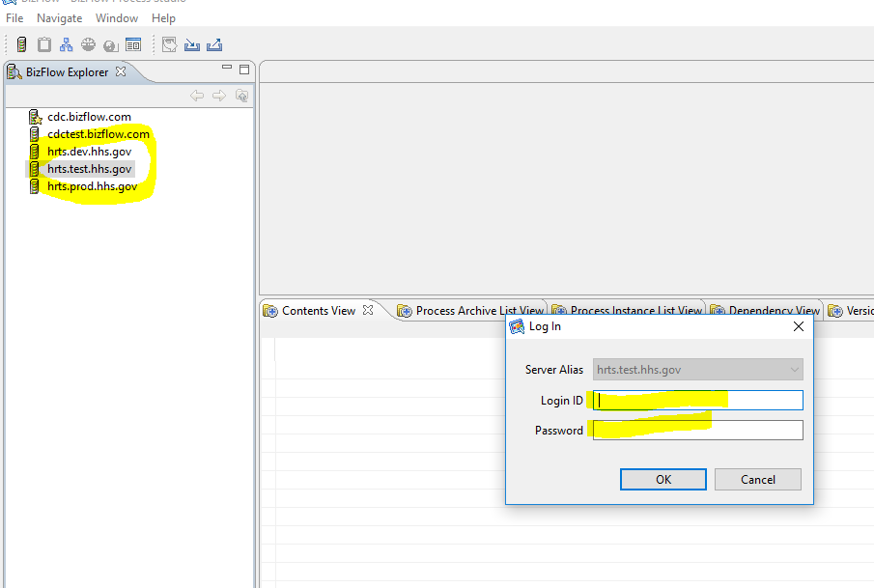

1. Step 3 - Click “Import” button.

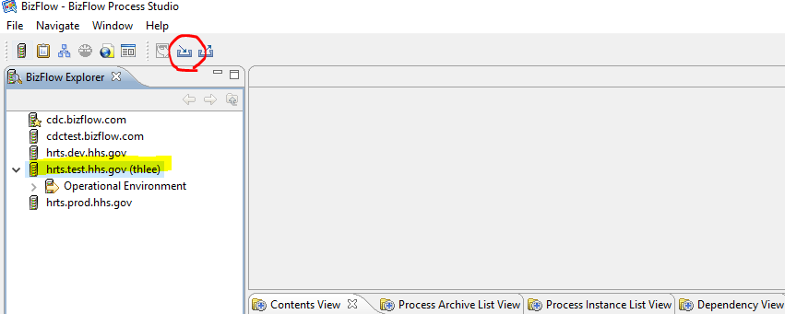

1. Step 4 - Select BizFlow BIX file.
2. Select proper server alias name in “Target Server” section.
   1. This is very important to make sure that you logged into right target server.
3. Click “Browse” button and select “CDC_EWITS2.bix” file.
4. Click “Next” button.

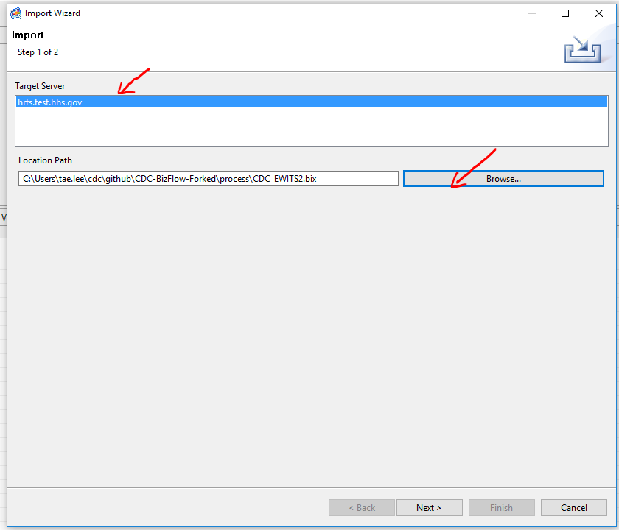

1. Step 5 - Click “+” icon to expand items and select “/Operational Environment/User Configuration/Authentication/Root”.

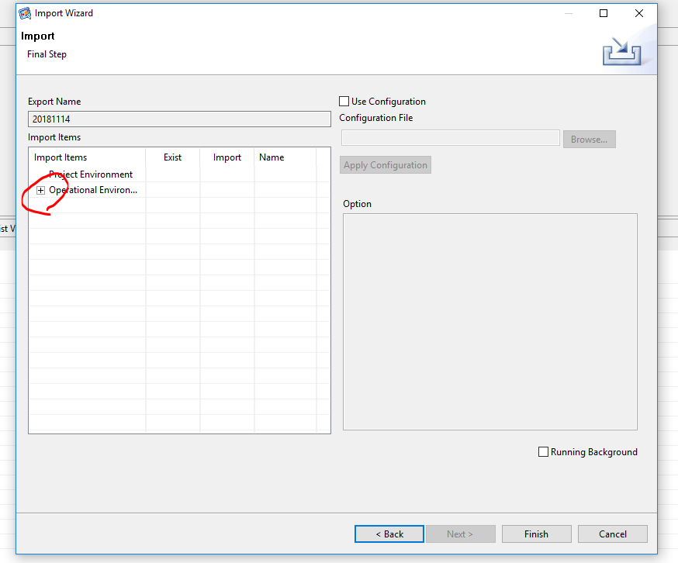

1. Step 6 - Uncheck “Create Users” option.
2. Import column should be set as “No”.

**Note**: The Create User option may be turned on in case user login accounts should be migrated, but in general, it should not be used. In the future deployment package, the test user entry may be excluded so that you may skip the Step 6.

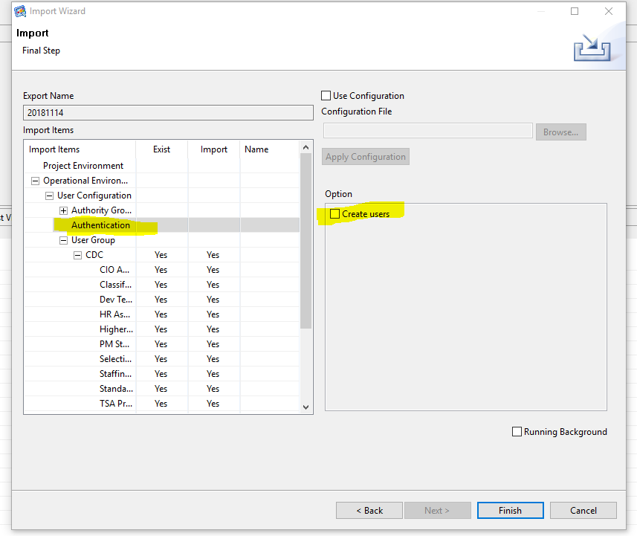

1. Step 7 - Uncheck “Link Users” option in “/Operational Environment/User Configuration/User Group”.

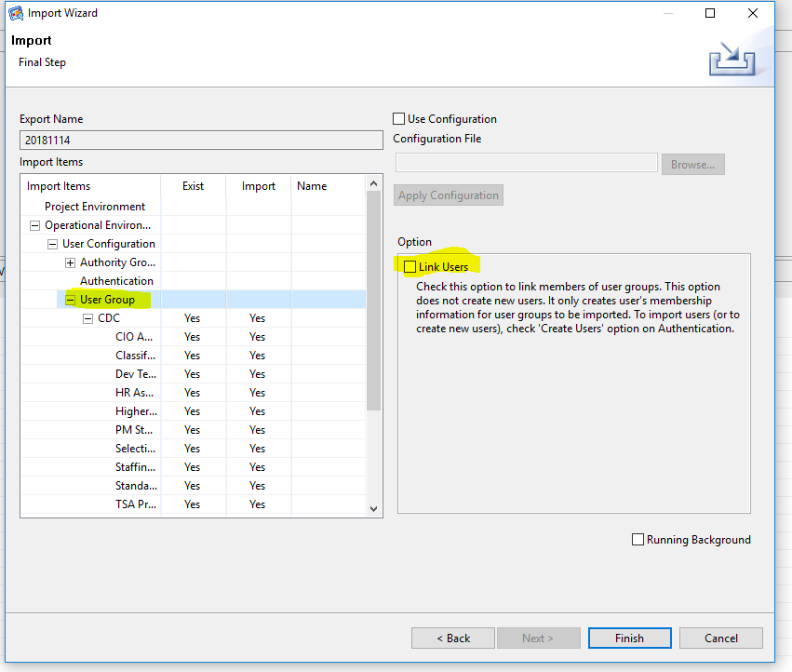

1. Step 8 - All user group under “/Operational Environment/User Configuration/User Group/CDC” should have “Yes” in “Import” column.

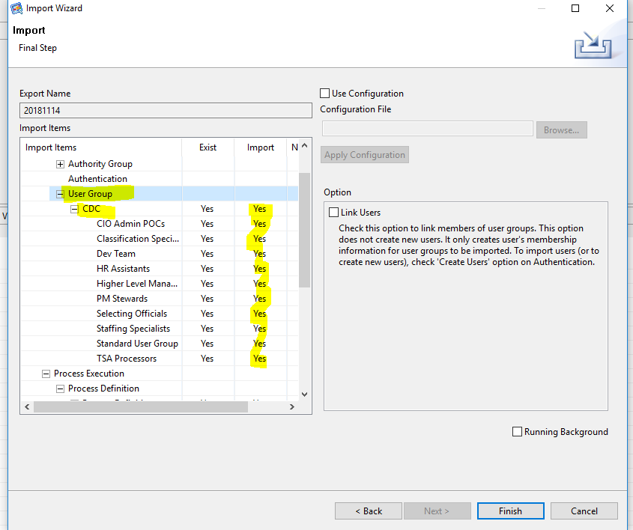

1. Step 9 - All Process Definitions under “/Operational Environment/Process Execution/Process Definition/Process Definitions/CDC” should have “Yes” in “Import” column.

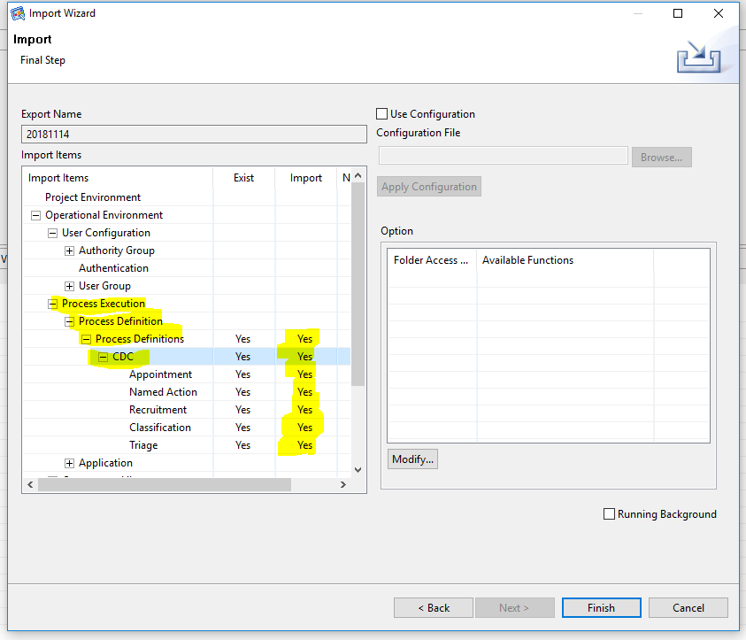

1. Step 10 - Application
2. Expand Operational Environment/Application/Application
3. Check the port number of application is correct. If port number is different, click on ;Find and Replace’ button to replace the URL to correct port number.
   1. As of November 14, 2018, Tomcat port numbers are
      1. DEV: 8080
      2. QA: 9080
      3. PROD: 8080

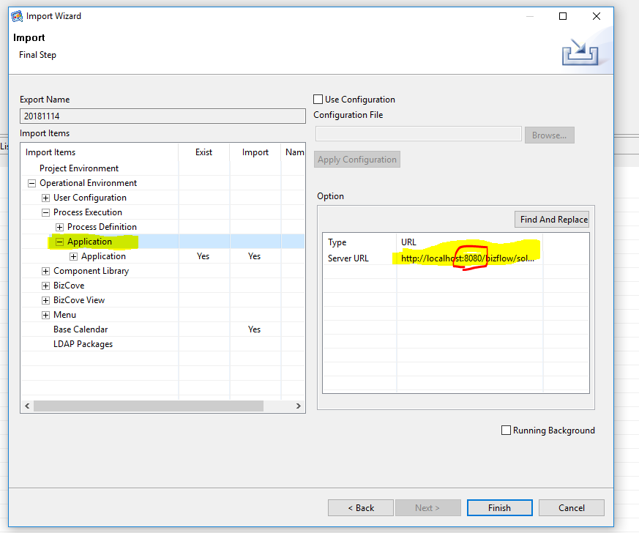

1. All Applications under “/Operational Environment/Application/Application/CDC” should have “Yes” in “Import” column”.

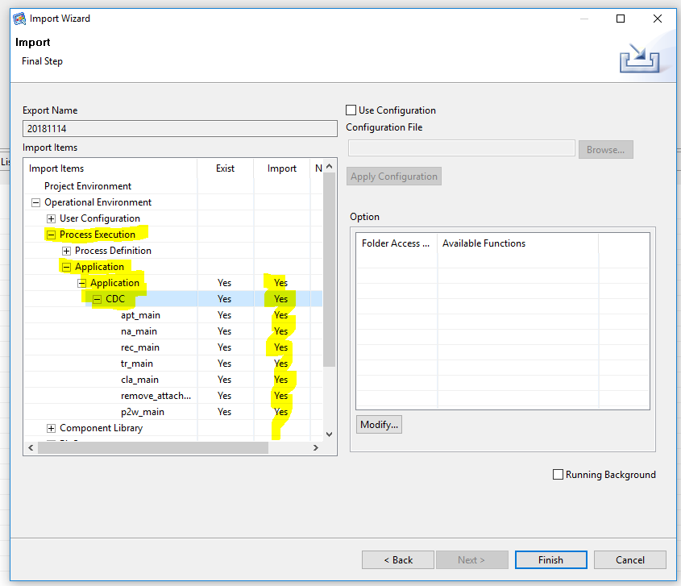

1. Step 12 - BizCove
2. All BizCoves should be set to “Yes” in Import column.

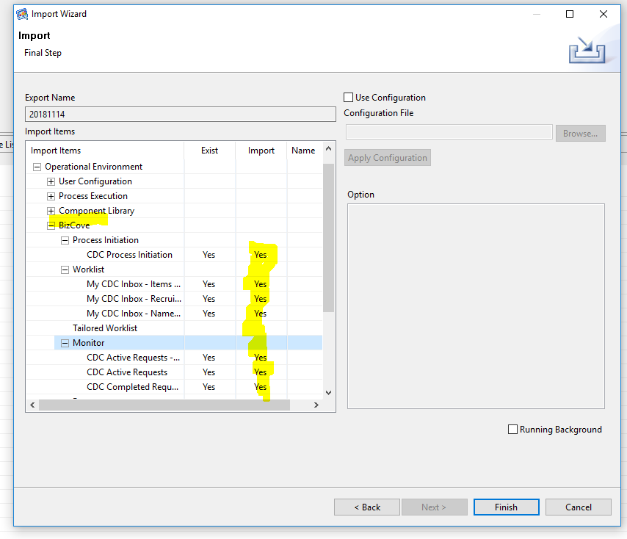

1. Step 13 - All BizCove View under “/Operational Environment/BizCove View” should have “Yes” in Import column.

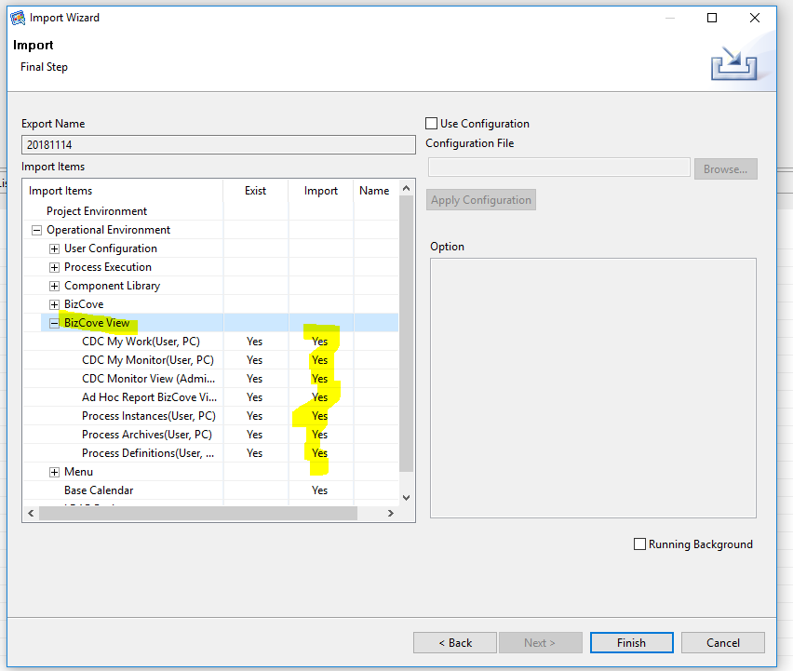

1. Step 14 - All Menu under “/Operational Environment/Menu” should have “Yes” in Import column.

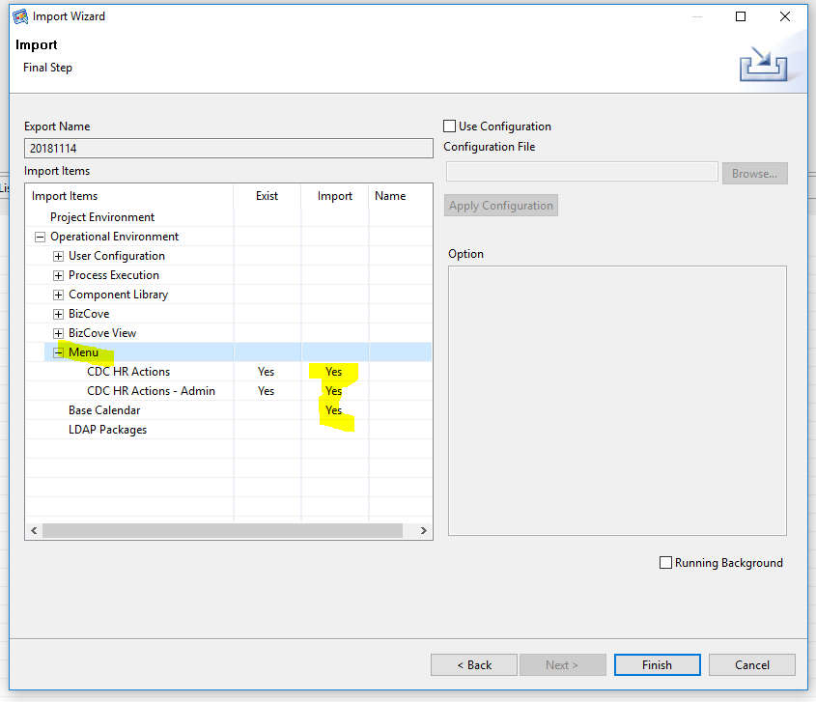

1. Step 15 - Click “OK” button and check log files.

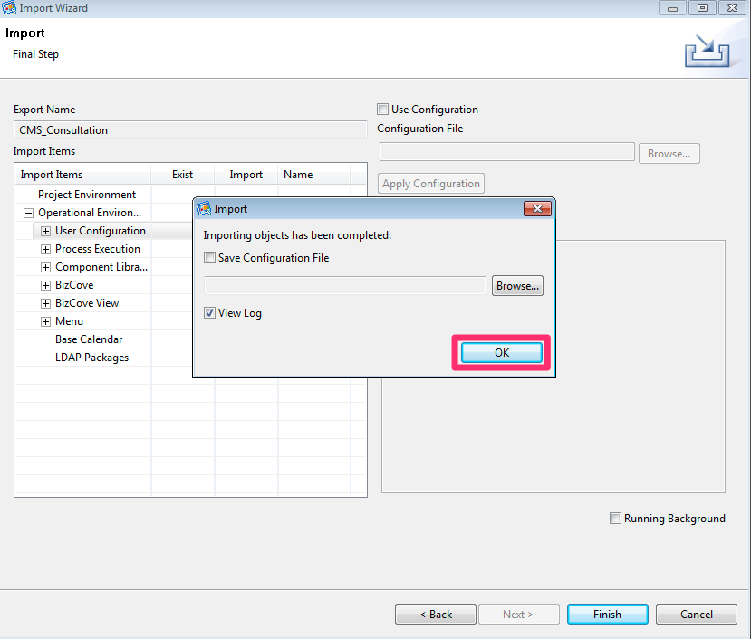

1. Repeat Step 1 through Step 16 per each environments.

## Report Deployment

It is assumed that BizFlow Advanced Reporting (BAR) is installed on the server. In order to deploy report files to the reporting server, we need to install BAR Deployment Tool. Normally, BAR Deployment Tool is installed as part of the BAR server component on the server machine, especially Windows based server environments. However, the BAR for Linux has known issues at the moment. As a workaround, BAR Deployment Tool needs to be installed on a Windows machine that has network connection to the BAR server machine, and the user will execute the deployment tool in the Windows machine’s command line.

1. On the designated Windows machine, copy the BAR installation file (BizFlow_Advanced_Reporting_12.4.zip) and extract it in a temporary directory.
2. From the extracted directory, copy **BizFlowReporting** directory and its contents to a designated directory which the user has full access to.

For example:

C:\Users\john.doe\BAR\BizFlowReporting\

1. Open js.jdbc.properties file in a text editor, and update the following database connection information entries to point to the target environment’s BAR database.

For example:

C:\Users\john.doe\BAR\BizFlowReporting\buildomatic\build_conf\default\js.jdbc.properties

Make sure the properties are set as the following, with the appropriate values for the highlighted portion per each target environment.

**WARNING**: Before running any import or export command, make sure the connection information in the file is correct for the target environment. Failing to verifying the correct database connection information may result in overwriting report definition and dependent report constructe. Such failure may cause error or put the report structure in inconsistent state.

**metadata.hibernate.dialect**=com.jaspersoft.ji.hibernate.dialect.OracleJICustomDialect

**metadata.jdbc.driverClassName**=oracle.jdbc.driver.OracleDriver

**metadata.jdbc.url**=jdbc:oracle:thin:@dbhost:1521:sid

**metadata.jdbc.username**=bizflowreport

**metadata.jdbc.password**=*password_of_bizflowreport_db_login*

**propsToEncrypt**=metadata.jdbc.password

**encrypt**=false

The database connection information (DB server name, port number, and SID/Service Name, password) of BIZFLOWREPORT schema for each environment should be acquired from DBA team.

1. Open a command line, and change directory to the BAR build directory (buildomatic).

For example:

cd C:\Users\john.doe\BAR\BizFlowReporting\buildomatic

1. For the first time report import, export the current report data source information as a backup. You will need to use this each time report is imported. Create the data source export for each of the target environment.

For each environment, make JDBC connection info for the target database in the js.jdbc.properties file, and run the export command. Repeat the setting JDBC information and export command for each target environment.

js-export.bat --output-zip hhscdcreport_datasource_dev.zip --uris /organizations/organization_1/datasources/BizFlow_Data_Source

js-export.bat --output-zip hhscdcreport_datasource_qa.zip --uris /organizations/organization_1/datasources/BizFlow_Data_Source

js-export.bat --output-zip hhscdcreport_datasource_prd.zip --uris /organizations/organization_1/datasources/BizFlow_Data_Source

Once the data source back up is created, we can re-use this in the future and do not need to back up data source each time unless there is data source connection information change

1. Copy report export file in the buildomatic directory.

For example:

copy *CDCReports.zip* C:\Users\john.doe\BAR\BizFlowReporting\buildomatic\

1. In the buildomatic directory, execute import command to import the report to BAR server for the target environment.

For example:

js-import --update --skip-user-update --input-zip *CDCReports.zip*

**Note**: The report export zip file contains the data source information of the database for the report development environment from which the export file is generated. By importing the export zip file, the database connection information of the target BAR server is overwritten. Therefore, we will need to restore the data source information of the target environment using the backup file in the next step.

1. In the buildomatic directory, execute import command to import the data source backup file so that the correct data source connection information is restored for the target environment.

For example:

js-import --update --skip-user-update --input-zip hhscdcreport_datasource_dev.zip

## BizFlow Rule Microservice Deployment

**Notes**: this Micro Rule Service was initially used for CDC HR project, but CMS HR project recently adapted the Rule Service engine. Therefore, if BizFlowRule has been deployed already, you can skip this step.

## How to check if BizFlow Rule Microservice already installed

You can verify if the BizFlowRule service’s installed on the environment by checking a web page exists.

1. Connect VPN if you are not in HHS network
2. Open a web browser
3. Go to https://<your_server_address>/bizflowrule/
   1. For examples,
      1. <https://hrts.test.hhs.gov/bizflowrule/>
      2. <https://hrts.dev.hhs.gov/bizflowrule/>
      3. <https://hrts.prod.hhs.gov/bizflowrule/>
4. If you can see the web page below, BizFlow Rule Microservice already exists, you do not need to deploy BizFlow Rule Microservice Engine.

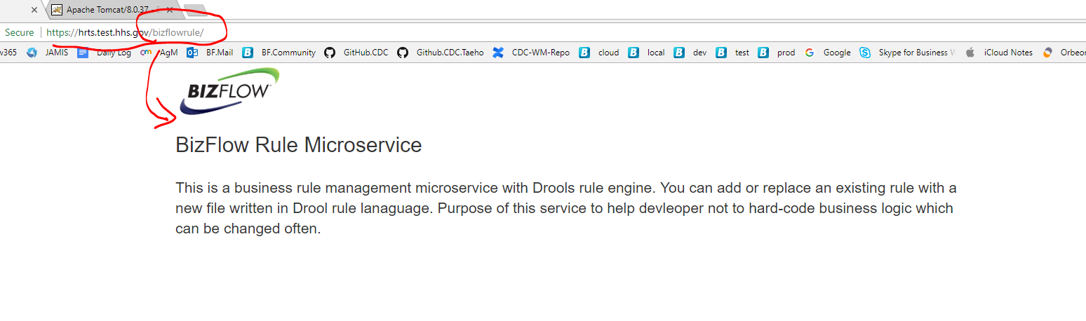

## How to check if BizFlow Rule Microservice already installed

If BizFlow Rule Microservice Engine has not been installed, you will need to deploy bizflowrule.war to Tomcat server. You can find the bizflowrule.war within the release zip file or CDC github repository directly.

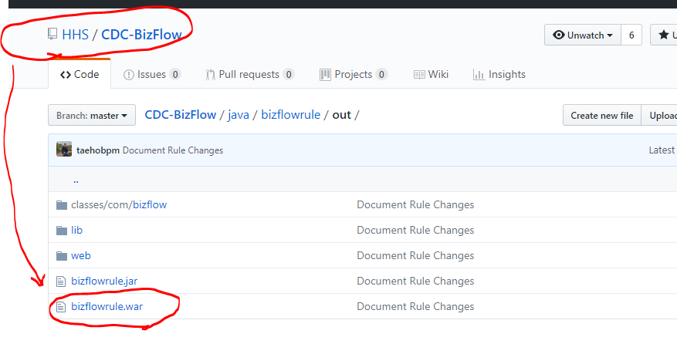

1. copy **bizflowrule.war** to <tomcat_dir>/webapps directory
2. once the war file is copied under the directory, Tomcat server will automatically deploy war to web application. There is no further action needed.

## UI Module Packaging

UI modules are captured from DEV environment's web application directory, using ANT build file.

The ANT build file will package the UI modules in a zip file. Especially for WebMaker runtime files, the script will capture configuration files separately per environment, which will be deployed to the target environment appropriately by the deployment script later on. The script also appends timestamp to the JavaScript and CSS file references in the web application files so that the web browser cache is forced to be refreshed at the first time loading after the new deployment.

## Pre-requisite on DEV Server

* JDK/JRE 1.7
* Apache Ant 1.9.x or later
* Administrator (or sudo) access to DEV server machine
* UI modules are deployed and tested in DEV server, and ready for promotion to higher environments (e.g. QA and PROD)
  + WebMaker form runtime files
  + BizFlow solution files

## Packaging Steps

**Notes**: For deployment purpose, You can skip this Packaging steps. These steps are only for someone who wants to package WebMaker form and Web applications.

1. Login to DEV server machine with an administrator (or sudo) account.
2. In the command line prompt, create a work directory where files will be generated, and change directory to it.

For example:

mkdir -p work/deploy

cd work/deploy

1. Copy UI packaging script to the deployment directory.

* From (source repository):

deploy/build.xml

* To (target environment):

*<DEV_server_dir>*/work/deploy/

1. Using a text editor, modify the following property value in the build.xml file for tomcat web application directory setting. Specify the full path to the tomcat directory.

***<property name="webserver.dir" value="full_path_to_tomcat_directory" />***

1. In the command line prompt, run ANT. The following will execute the default target, which will generate a zip file.

ant

1. Capture the generated zip file. The packaging script will create the intermediate directories and generate the UI runtime zip file with timestamp suffix.

For example:

*<DEV_server_dir>*/work/deploy/deployment/ui/runtime_*20181114_132525*.zip

## Web Application (UI Module) Deployment

UI modules are deployed to the higher environments (e.g. QA, PROD) using shell scripts.

Please note that the script files are shared across other opDivs project. The deployment script will stop tomcat service, copy runtime files to tomcat web application directory, and start tomcat service.

1. Login to higher environment server machine with an administrator (or sudo) account.
2. In the command line prompt, create a work directory where the deployment package file will be placed, and change directory to it.

For example:

mkdir -p work/deploy/baseline/ui

cd work/deploy

1. Copy UI deployment script to the deployment directory.

* From (source repository):

deploy/deploy_ui.sh prod

* To (target environment):

<DEV_server_dir>/work/deploy/

1. Using a text editor, modify the following property value in the ui.properties file for tomcat web application directory setting. Specify the full path to the tomcat directory.

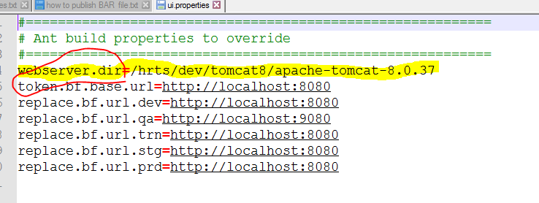

1. In the command line prompt, make the UI deployment script mode executable.

For example:

chomod 744 deploy_ui.sh

1. Copy UI deployment package file to the UI deployment directory.

For example:

* From (source repository):

runtime_cdc_20181114_132525.zip

* To (target environment):

*<DEV_server_dir>*/work/deploy/baseline/ui

1. In the command line prompt, extract the UI runtime zip file. If there is previous extract of runtime files, remove it before fresh extract.

For example:

cd baseline/ui

rm -rf runtime

unzip runtime_cdc_20181114_132525.zip

1. In the command line prompt, change directory back to the deployment directory, and run the deployment script.

For example:

cd <DEV_server_dir>/work/deploy

./deploy_ui.sh prod -nodebug

Note: The deployment script has "-nodebug" option for real deployment action. If you run the script without the option, it will try to test directory setting without actually deploying any file. This is a precautionary measure to prevent accidental overwriting of the target application files. In order to run the deployment script in "DEBUG" mode, i.e. without "-nodebug" option, a dummy script should be placed in the deployment directory. Make sure the dummy script mode is executable.

# BizFlow Global Variable Configuration

After the first deployment of BIX file, the Global Variable should be configured for each environment. Any subsequent BIX import will not overwrite the value of the variable. The value must be set manually per environment. Currently, there is only one Global Variable.

* **cdcEmailDisclaimer** - Disclaimer that is displayed in system-generated emails
* **adminEmailAddress** - Email address used to send CDC system-generated emails

In order to set the value, follow the steps below.

1. Open BizFlow Process Studio (BPS), and log in to the target server.
2. Open Operational Environment > Component Library from BizFlow Explorer pane, and select Global Variable.
3. In Content View, right-click on the variable, then choose Modify menu item.

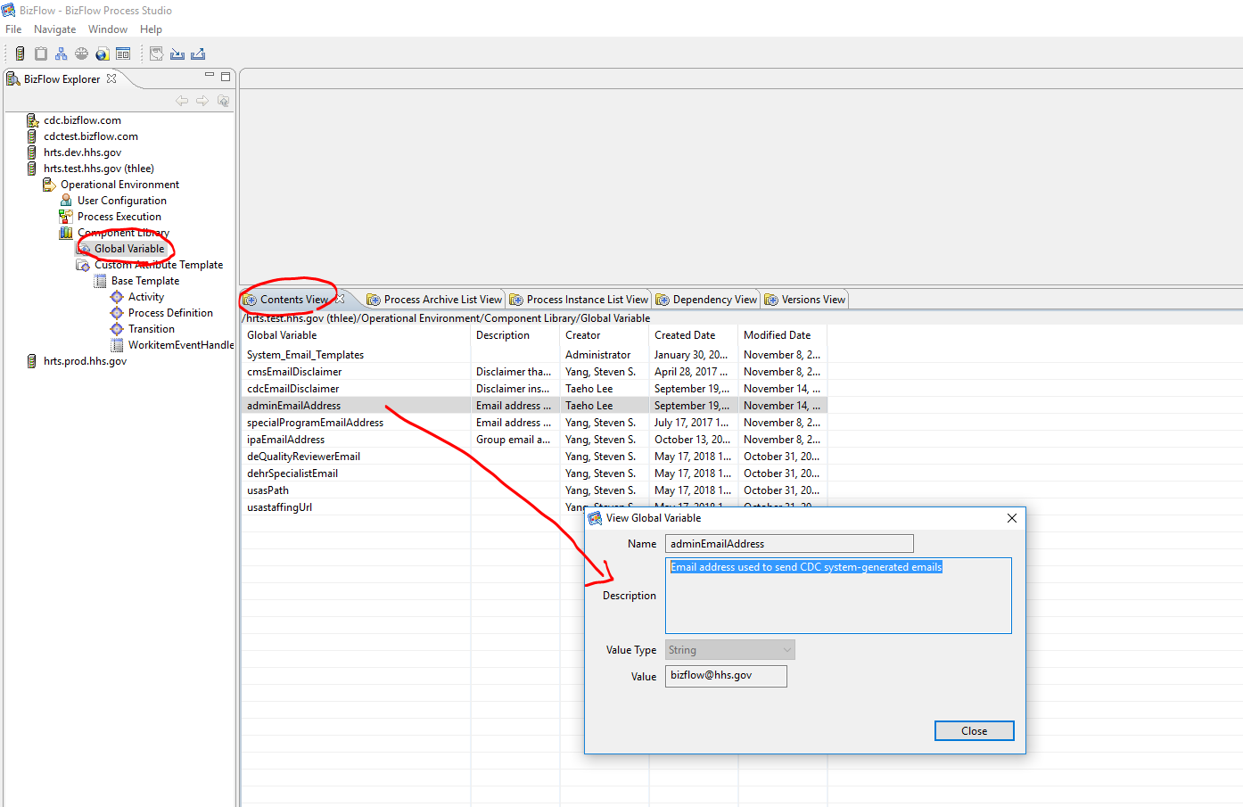

1. In Modify dialog, set the content of Value field as appropriate.

For example: Replies will be sent to an unmonitored mailbox. Please do not respond to this email.

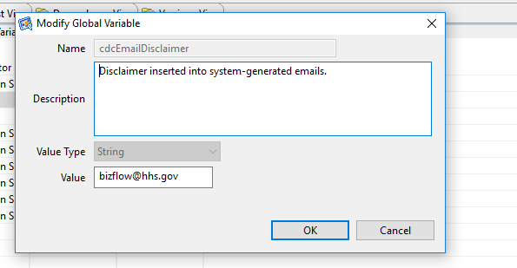

# BizFlow ERA Configuration

In this instruction, a user login “import_user” is assumed to be set up with the necessary permission. In order to verify the BizFlow user with proper permission, log in to BizFlow Portal site as a system administrator, and check the Authentication configuration.

1. Log in to BizFlow Portal as a system administrator.
2. Click “ADMINISTRATION” tab on the top right corner.

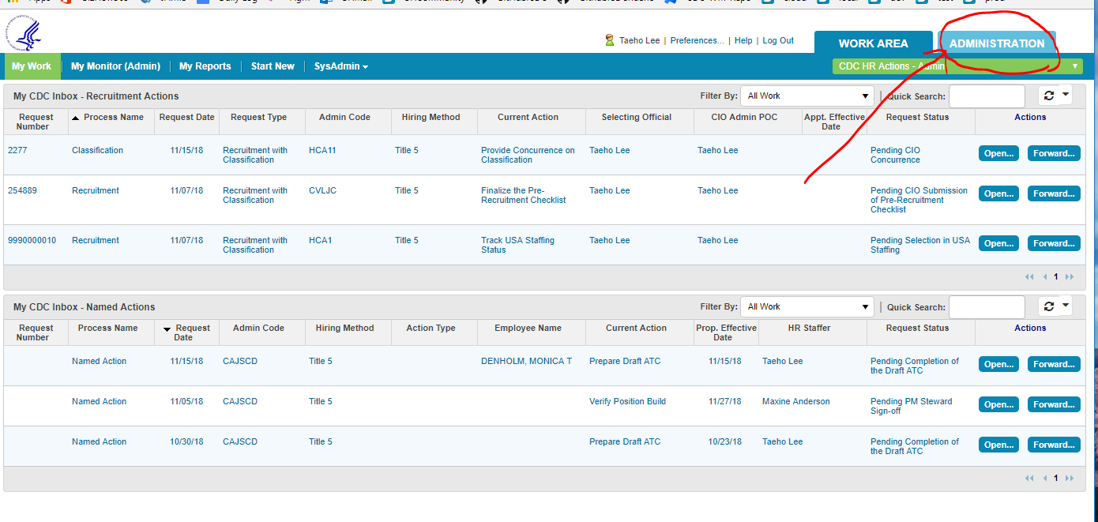

1. Click “Event Response” on the administration page

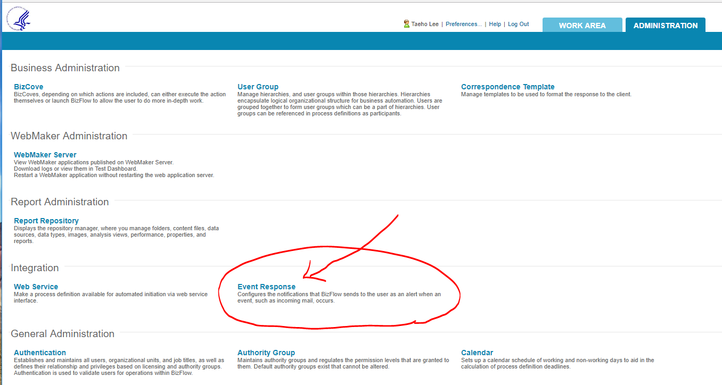

## CDC – CapHR – JR ERA service

1. Click on “Launch Event Reponse Designer Wizard” button

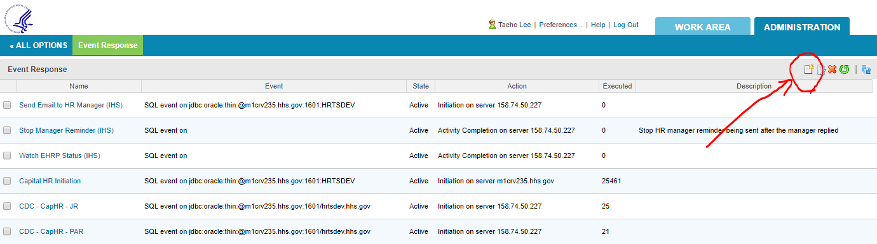

1. Event Type
   * Event Type: SQL
   * Name: CDC – CapHR – JR
   * Click “Next”

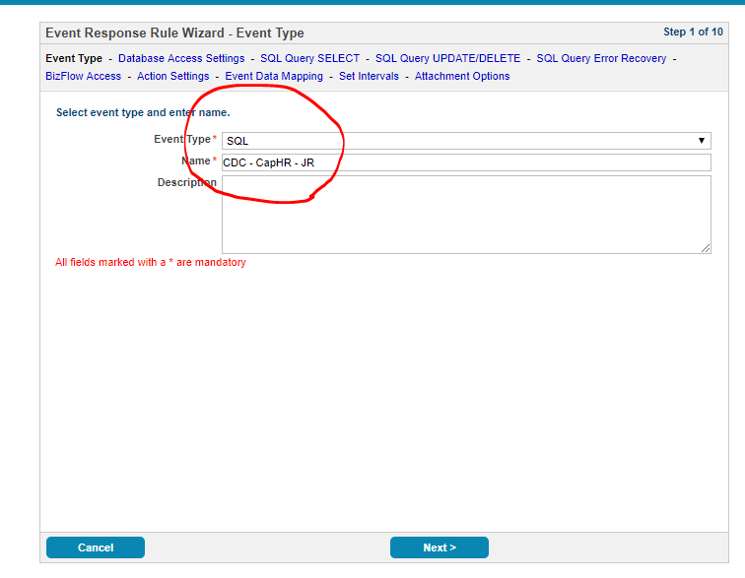

1. Data Access Settings
   * JDBC driver Information: oracle.jdbc.driver.OracleDriver
   * JDBC database location URL: type Production server’s JDBC URL
   * JDBC user name: production BizFlow database user name
   * JDBC password: production BizFlow database password

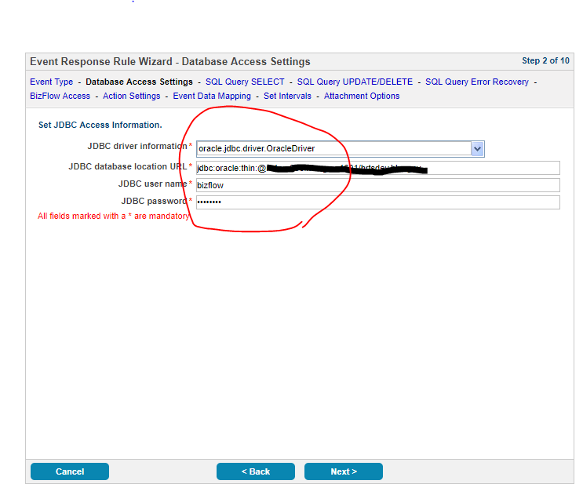

1. SQL Query – SELECT
   * Copy query below and paste to SQL SELECT query field.
     1. Note: Check if MS Word converts single or double quote to special character. They should be ansi single or double quote character. You can find the same query in era directory in the release1.x.zip file.
   * Click Next

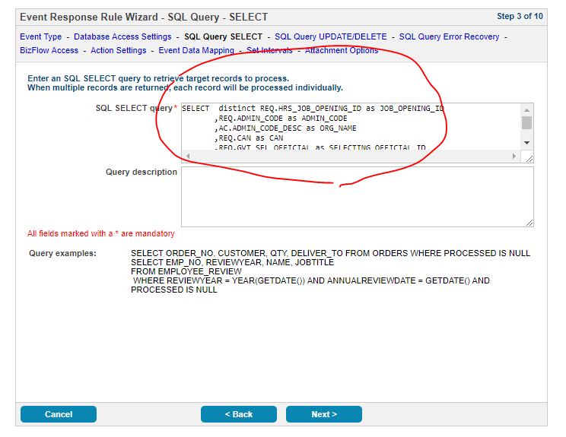

|  |
| --- |
| SELECT distinct REQ.HRS_JOB_OPENING_ID as JOB_OPENING_ID  ,REQ.ADMIN_CODE as ADMIN_CODE  ,AC.ADMIN_CODE_DESC as ORG_NAME  ,REQ.CAN as CAN  ,REQ.GVT_SEL_OFFICIAL as SELECTING_OFFICIAL_ID  ,DECODE(M_SO.MEMBERID, NULL, NULL, '[U]' || M_SO.MEMBERID) AS SELECTING_OFFICIAL_MID  ,M_SO.NAME AS SELECTING_OFFICIAL_NAME  ,M_SO.EMAIL AS SELECTING_OFFICIAL_EMAIL  ,REQ.GVT_STAFF_SPCLST as STAFF_SPCLST_ID  ,DECODE(M_SS.MEMBERID, NULL, NULL, '[U]' || M_SS.MEMBERID) AS STAFF_SPCLST_MID  ,M_SS.NAME AS STAFF_SPCLST_NAME  ,M_SS.EMAIL AS STAFF_SPCLST_EMAIL  ,REQ.ORIGINATOR_ID as CIO_ADMIN_ID  ,DECODE(M_CA.MEMBERID, NULL, NULL, '[U]' || M_CA.MEMBERID) AS CIO_ADMIN_MID  ,M_CA.NAME AS CIO_ADMIN_NAME  ,M_CA.EMAIL AS CIO_ADMIN_EMAIL  ,dbms_lob.substr( REQ.HE_COMMENTS, 4000, 1 ) AS REMARKS  ,REQ.STATUS_DT AS STATUS_DT  ,REQ.CREATE_DATE AS CREATIONDTIME  FROM HHS_HR.VW_EHRP_15_MIN REQ  LEFT OUTER JOIN HHS_HR.PS_OPR_DEFN P_SO ON P_SO.OPRID = REQ.GVT_SEL_OFFICIAL  LEFT OUTER JOIN HHS_HR.PS_OPR_DEFN P_SS ON P_SS.OPRID = REQ.GVT_STAFF_SPCLST  LEFT OUTER JOIN HHS_HR.PS_OPR_DEFN P_CA ON P_CA.OPRID = REQ.ORIGINATOR_ID  LEFT OUTER JOIN BIZFLOW.MEMBER M_SO ON lower(M_SO.EMAIL) = lower(P_SO.EMAILID)  LEFT OUTER JOIN BIZFLOW.MEMBER M_SS ON lower(M_SS.EMAIL) = lower(P_SS.EMAILID)  LEFT OUTER JOIN BIZFLOW.MEMBER M_CA ON lower(M_CA.EMAIL) = lower(P_CA.EMAILID)  LEFT OUTER JOIN HHS_HR.ADMINISTRATIVE_CODE AC ON AC.ADMIN_CODE = REQ.ADMIN_CODE  WHERE REQ.BUSINESS_UNIT = 'CDC00'  AND NOT EXISTS (SELECT 1  FROM HHS_CDC_HR.ERA_LOG_CAPHR_JR ERA  WHERE ERA.JOB_OPENING_ID = REQ.HRS_JOB_OPENING_ID)  AND REQ.CREATE_DATE >= (  SELECT LAST_RUN_DTIME  FROM (  SELECT LAST_RUN_DTIME  FROM HHS_CDC_HR.ERA_LOG_CAPHR_LAST_RUN  WHERE ERA_SVC_TYPE = 'CAPHR-ERA-JR'  UNION  SELECT (SYSDATE - 7)  FROM DUAL  ) TMP  WHERE ROWNUM = 1  AND LAST_RUN_DTIME IS NOT NULL  )  ORDER BY REQ.CREATE_DATE DESC |

1. SQL Query – UPDATE/DELETE
   * Copy query below and paste to SQL SELECT UPDATE/DELETE field.
   * Click Next

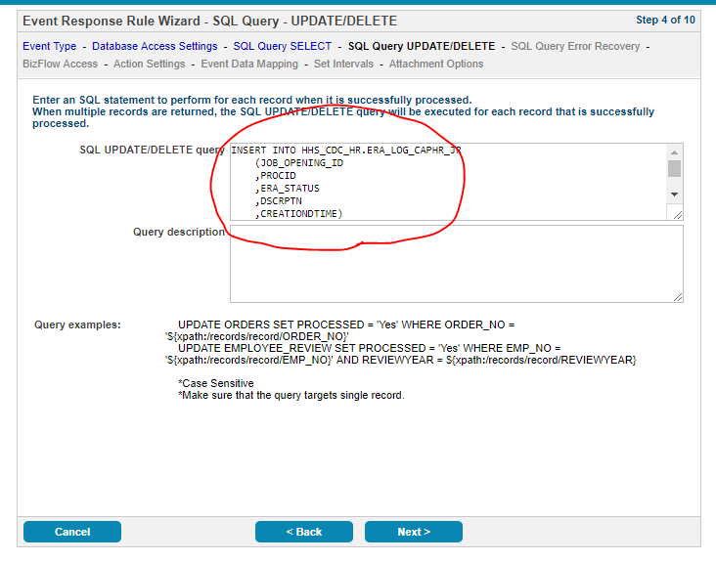

|  |
| --- |
| INSERT INTO HHS_CDC_HR.ERA_LOG_CAPHR_JR  (JOB_OPENING_ID  ,PROCID  ,ERA_STATUS  ,DSCRPTN  ,CREATIONDTIME)  VALUES  ('${xpath:/records/record/JOB_OPENING_ID}'  ,1  ,'PROCESSED'  ,q'[${xpath:/records/record/REMARKS}]'  ,SYSDATE) |

1. SQL Query – Error Recovery
   * Copy query below and paste to **SQL error recovery statement** field.
   * Click Next

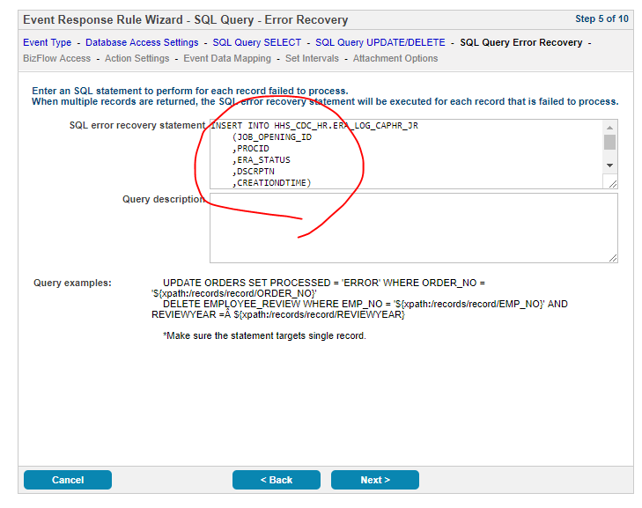

|  |
| --- |
| INSERT INTO HHS_CDC_HR.ERA_LOG_CAPHR_JR  (JOB_OPENING_ID  ,PROCID  ,ERA_STATUS  ,DSCRPTN  ,CREATIONDTIME)  VALUES  ('${xpath:/records/record/JOB_OPENING_ID}'  ,1  ,'ERROR'  ,q'[${xpath:/records/record/REMARKS}]'  ,SYSDATE) |

1. BizFlow Access
   * BizFlow server name or IP: Type production server IP address
   * BizFlow port: Type production server BizFlow port number. Default is 7201.
   * BizFlow ERA user ID: agentuser
   * BizFlow ERA password: type password agentuser. Default is st1ceqef
     1. If the password is changed, you will need to change the password webapps/bizflow/solutions/hhs/cdc/cdc.properties file.

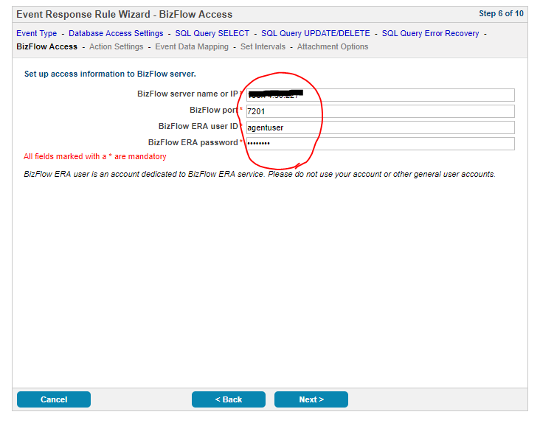

1. Action Settings
   * Click “Select” button

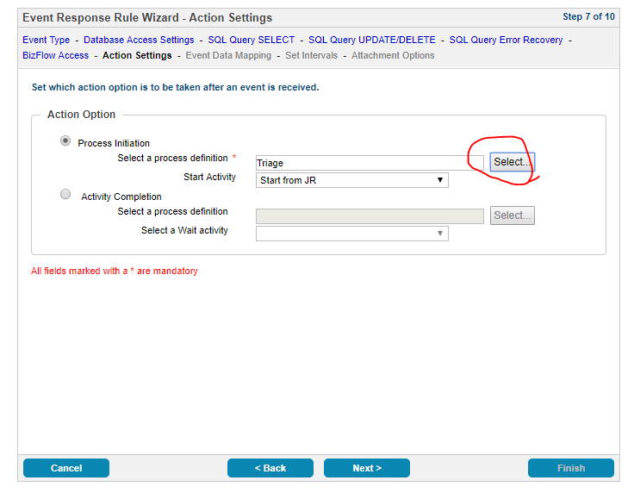

* + Select “Triage” under CDC.

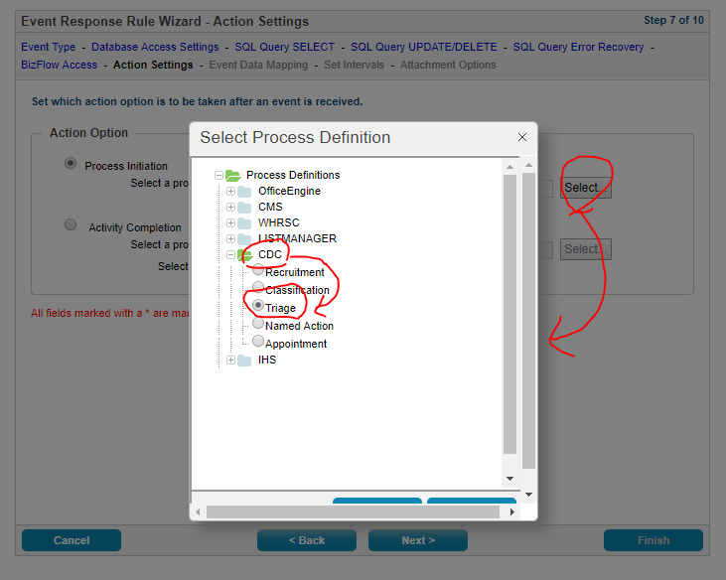

* + Select “Start from JR” in the Start Activity dropdown list
  + Click “Next”

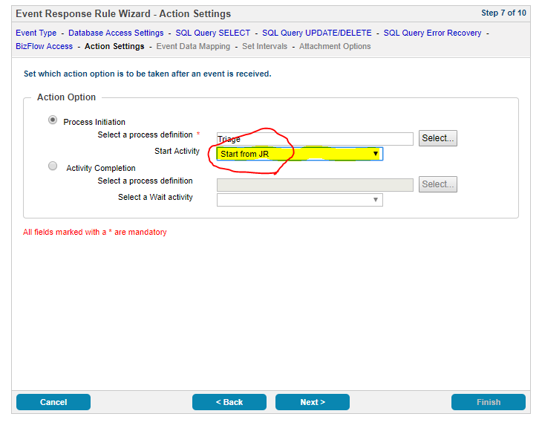

1. Map Columns to Process Variables
   * Map Columns to Process Variables
     1. REMARKS to remkarks
     2. CAN to can
     3. ORG_NAME to orgName
     4. ADMIN_CODE to adminCode
     5. JOB_OPENING_ID to jobRequestNum
   * Click “Next”

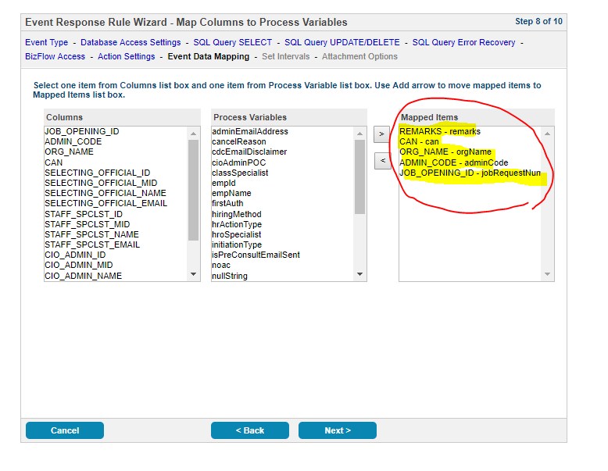

1. Set Intervals
   * Set Interval period: 1 hours
   * Check “No expiration date or time” in “Set event reponse expiration cirteria” radio button group.
   * Click “Next”

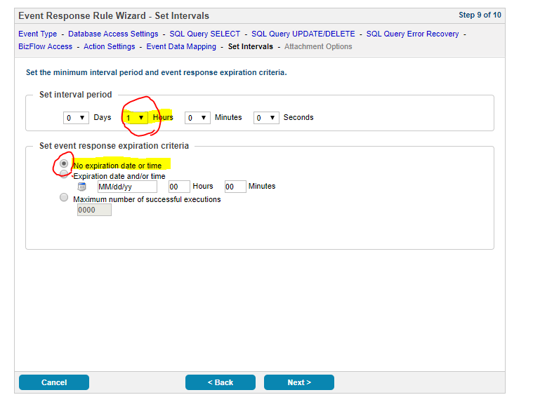

1. Attachment Options
   * Click “Finish”

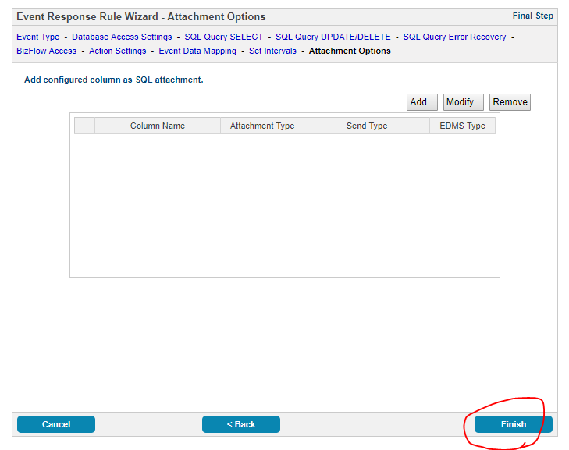

## CDC – CapHR – PAR ERA service

1. Click on “Launch Event Reponse Designer Wizard” button



1. Event Type
   * Event Type: SQL
   * Name: CDC – CapHR – PAR
   * Click “Next”

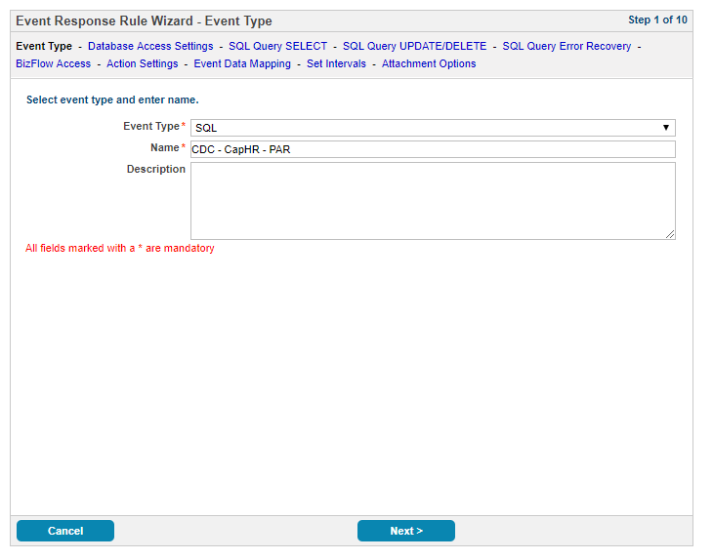

1. Data Access Settings
   * JDBC driver Information: oracle.jdbc.driver.OracleDriver
   * JDBC database location URL: type Production server’s JDBC URL
   * JDBC user name: production BizFlow database user name
   * JDBC password: production BizFlow database password



1. SQL Query – SELECT
   * Copy query below and paste to SQL SELECT query field.
     1. Note: Check if MS Word converts single or double quote to special character. They should be ansi single or double quote character. You can find the same query in era directory in the release1.x.zip file.
   * Click Next

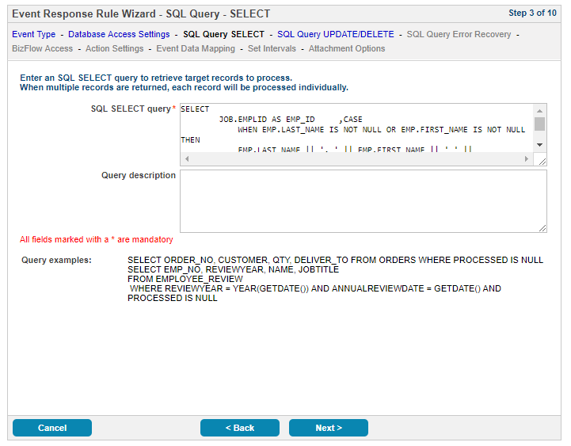

|  |
| --- |
| SELECT  JOB.EMPLID AS EMP_ID ,CASE  WHEN EMP.LAST_NAME IS NOT NULL OR EMP.FIRST_NAME IS NOT NULL THEN  EMP.LAST_NAME || ', ' || EMP.FIRST_NAME || ' ' || SUBSTR(EMP.MIDDLE_NAME, 0, 1)  END AS EMP_NAME  ,JOB.DEPTID AS ADMIN_CODE  ,AC.ADMIN_CODE_DESC AS ORG_NAME  ,TO_CHAR(JOB.GVT_EFFDT, 'YYYY/MM/DD HH24:MI:SS') AS GVT_EFFDT_FORMATTED  ,TO_CHAR(JOB.GVT_EFFDT_PROPOSED, 'YYYY/MM/DD HH24:MI:SS') AS GVT_EFFDT_PROPOSED_FORMATTED  ,JOB.ACTION AS PAR_ACTION  ,JOB.ACTION_REASON AS PAR_ACTION_REASON  ,JOB.GVT_WIP_STATUS AS PAR_STATUS  ,JOB.GVT_NOA_CODE  ,TRIM(JOB.GVT_LEG_AUTH_1 || ' ' || GVT_PAR_AUTH_D1 || ' ' || GVT_PAR_AUTH_D1_2) AS FIRST_AUTH  ,TRIM(JOB.GVT_LEG_AUTH_2 || ' ' || GVT_PAR_AUTH_D2 || ' ' || GVT_PAR_AUTH_D2_2) AS SECOND_AUTH  ,EMP.CAN_CD AS CAN  ,LISTAGG(  TRIM(RMK.GVT_REMARK_LINE1)  || DECODE(TRIM(RMK.GVT_REMARK_LINE2), NULL, '', chr(13) || chr(10) || RMK.GVT_REMARK_LINE2)  || DECODE(TRIM(RMK.GVT_REMARK_LINE3), NULL, '', chr(13) || chr(10) || RMK.GVT_REMARK_LINE3)  || DECODE(TRIM(RMK.GVT_REMARK_LINE4), NULL, '', chr(13) || chr(10) || RMK.GVT_REMARK_LINE4)  || DECODE(TRIM(RMK.GVT_REMARK_LINE5), NULL, '', chr(13) || chr(10) || RMK.GVT_REMARK_LINE5)  || DECODE(TRIM(RMK.GVT_REMARK_LINE6), NULL, '', chr(13) || chr(10) || RMK.GVT_REMARK_LINE6)  || DECODE(TRIM(RMK.GVT_REMARK_LINE7), NULL, '', chr(13) || chr(10) || RMK.GVT_REMARK_LINE7)  || DECODE(TRIM(RMK.GVT_REMARK_LINE8), NULL, '', chr(13) || chr(10) || RMK.GVT_REMARK_LINE8)  || DECODE(TRIM(RMK.GVT_REMARK_LINE9), NULL, '', chr(13) || chr(10) || RMK.GVT_REMARK_LINE9)  , ';' || chr(13) || chr(10) || chr(13) || chr(10)) WITHIN GROUP(ORDER BY RMK.EMPLID ) AS REMARKS  FROM HHS_HR.PS_GVT_JOB JOB  LEFT JOIN HHS_HR.PS_GVT_PAR_REMARKS RMK ON JOB.EMPLID = RMK.EMPLID AND JOB.EFFDT = RMK.EFFDT AND JOB.EMPL_RCD = RMK.EMPL_RCD AND JOB.EFFSEQ = RMK.EFFSEQ  LEFT JOIN HHS_HR.EMPLOYEE_LOOKUP EMP ON JOB.EMPLID = EMP.EMPLID  LEFT OUTER JOIN HHS_HR.ADMINISTRATIVE_CODE AC ON AC.ADMIN_CODE = JOB.DEPTID  WHERE JOB.BUSINESS_UNIT = 'CDC00'  AND JOB.GVT_WIP_STATUS = 'INI'  AND JOB.ACTION IN ('PRO','XFR','EXT','DEM','PAY','EZT')  AND NOT EXISTS (SELECT 1  FROM HHS_CDC_HR.ERA_LOG_CAPHR_PAR ERA  WHERE ERA.EMPLID = JOB.EMPLID  AND ERA.ADMIN_CODE = JOB.DEPTID  AND ERA.PAR_ACTION = JOB.ACTION  AND ERA.PAR_ACTION_REASON = JOB.ACTION_REASON  AND ERA.PAR_STATUS = JOB.GVT_WIP_STATUS  AND ERA.GVT_EFFDT = JOB.GVT_EFFDT  AND ERA.GVT_EFFDT_PROPOSED_DT = JOB.GVT_EFFDT_PROPOSED  )  AND JOB.EFFDT =  (  SELECT MAX(EFFDT)  FROM HHS_HR.PS_GVT_JOB  WHERE EMPLID = JOB.EMPLID  AND EMPL_RCD = JOB.EMPL_RCD  AND EFFSEQ = JOB.EFFSEQ  AND EFFDT >= (  SELECT LAST_RUN_DTIME  FROM (  SELECT LAST_RUN_DTIME  FROM HHS_CDC_HR.ERA_LOG_CAPHR_LAST_RUN WHERE ERA_SVC_TYPE = 'CAPHR-ERA-PAR'  UNION  SELECT (SYSDATE - 7)  FROM DUAL  ) TMP  WHERE ROWNUM = 1  AND LAST_RUN_DTIME IS NOT NULL  )  )  AND RMK.EFFDT =  (  SELECT MAX(EFFDT)  FROM HHS_HR.PS_GVT_PAR_REMARKS  WHERE EMPLID = RMK.EMPLID  AND EMPL_RCD = RMK.EMPL_RCD  AND EFFSEQ = RMK.EFFSEQ  AND EFFDT >= (  SELECT LAST_RUN_DTIME  FROM (  SELECT LAST_RUN_DTIME  FROM HHS_CDC_HR.ERA_LOG_CAPHR_LAST_RUN  WHERE ERA_SVC_TYPE = 'CAPHR-ERA-PAR'  UNION  SELECT (SYSDATE - 7)  FROM DUAL  ) TMP  WHERE ROWNUM = 1  AND LAST_RUN_DTIME IS NOT NULL  )  )  GROUP BY  JOB.EMPLID  ,CASE  WHEN EMP.LAST_NAME IS NOT NULL OR EMP.FIRST_NAME IS NOT NULL THEN  EMP.LAST_NAME || ', ' || EMP.FIRST_NAME || ' ' || SUBSTR(EMP.MIDDLE_NAME, 0, 1)  END  ,JOB.DEPTID  ,AC.ADMIN_CODE_DESC  ,TO_CHAR(JOB.GVT_EFFDT, 'YYYY/MM/DD HH24:MI:SS')  ,TO_CHAR(JOB.GVT_EFFDT_PROPOSED, 'YYYY/MM/DD HH24:MI:SS')  ,JOB.ACTION  ,JOB.ACTION_REASON  ,JOB.GVT_WIP_STATUS  ,JOB.GVT_NOA_CODE  ,TRIM(JOB.GVT_LEG_AUTH_1 || ' ' || GVT_PAR_AUTH_D1 || ' ' || GVT_PAR_AUTH_D1_2)  ,TRIM(JOB.GVT_LEG_AUTH_2 || ' ' || GVT_PAR_AUTH_D2 || ' ' || GVT_PAR_AUTH_D2_2)  ,EMP.CAN_CD |

1. SQL Query – UPDATE/DELETE
   * Copy query below and paste to SQL SELECT UPDATE/DELETE field.
   * Click Next

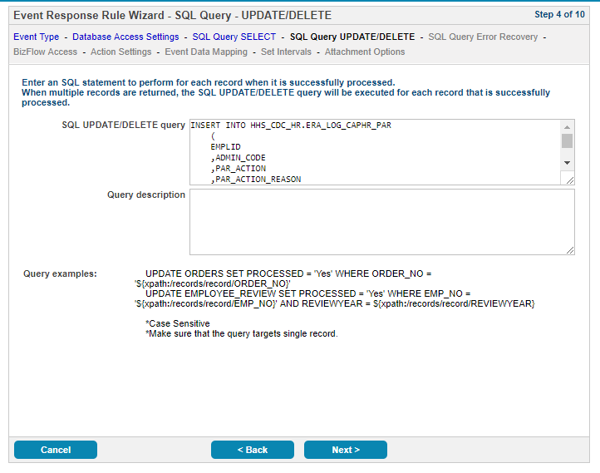

|  |
| --- |
| INSERT INTO HHS_CDC_HR.ERA_LOG_CAPHR_PAR  (  EMPLID  ,ADMIN_CODE  ,PAR_ACTION  ,PAR_ACTION_REASON  ,PAR_STATUS  ,GVT_EFFDT  ,GVT_EFFDT_PROPOSED_DT  ,PROCID  ,ERA_STATUS  ,DSCRPTN  ,CREATIONDTIME  )  VALUES  (  '${xpath:/records/record/EMP_ID}'  ,'${xpath:/records/record/ADMIN_CODE}'  ,'${xpath:/records/record/PAR_ACTION}'  ,'${xpath:/records/record/PAR_ACTION_REASON}'  ,'${xpath:/records/record/PAR_STATUS}'  ,TO_DATE('${xpath:/records/record/GVT_EFFDT_FORMATTED}', 'YYYY/MM/DD HH24:MI:SS')  ,TO_DATE('${xpath:/records/record/GVT_EFFDT_PROPOSED_FORMATTED}', 'YYYY/MM/DD HH24:MI:SS')  ,1  ,'PROCESSED'  ,q'[${xpath:/records/record/REMARKS}]'  ,SYSDATE) |

1. SQL Query – Error Recovery
   * Copy query below and paste to **SQL error recovery statement** field.
   * Click Next

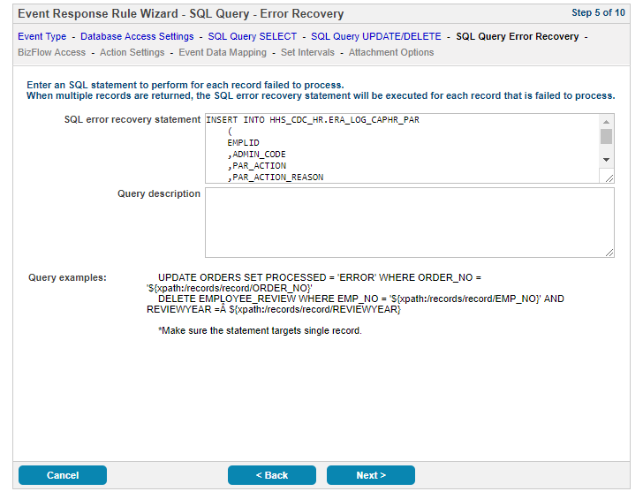

|  |
| --- |
| INSERT INTO HHS_CDC_HR.ERA_LOG_CAPHR_PAR  (  EMPLID  ,ADMIN_CODE  ,PAR_ACTION  ,PAR_ACTION_REASON  ,PAR_STATUS  ,GVT_EFFDT  ,GVT_EFFDT_PROPOSED_DT  ,PROCID  ,ERA_STATUS  ,DSCRPTN,CREATIONDTIME  )  VALUES  (  '${xpath:/records/record/EMP_ID}'  ,'${xpath:/records/record/ADMIN_CODE}'  ,'${xpath:/records/record/PAR_ACTION}'  ,'${xpath:/records/record/PAR_ACTION_REASON}'  ,'${xpath:/records/record/PAR_STATUS}'  ,TO_DATE('${xpath:/records/record/GVT_EFFDT_FORMATTED}', 'YYYY/MM/DD HH24:MI:SS')  ,TO_DATE('${xpath:/records/record/GVT_EFFDT_PROPOSED_FORMATTED}', 'YYYY/MM/DD HH24:MI:SS')  ,1  ,'ERROR'  ,q'[${xpath:/records/record/REMARKS}]'  ,SYSDATE) |

1. BizFlow Access
   * BizFlow server name or IP: Type production server IP address
   * BizFlow port: Type production server BizFlow port number. Default is 7201.
   * BizFlow ERA user ID: agentuser
   * BizFlow ERA password: type password agentuser. Default is st1ceqef
     1. If the password is changed, you will need to change the password webapps/bizflow/solutions/hhs/cdc/cdc.properties file.



1. Action Settings
   * Click “Select” button



* + Select “Triage” under CDC.



* + Select “Start from JR” in the Start Activity dropdown list
  + Click “Next”

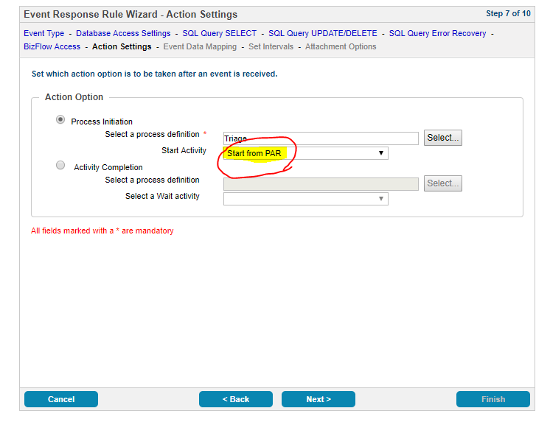

1. Map Columns to Process Variables
   * Map Columns to Process Variables
     1. REMARKS to remkarks
     2. CAN to can
     3. GVT_NOA_CODE to noac
     4. PAR_ACTION – parAction
     5. GVT_EFFDT_PROPSED - propEffectiveDate
     6. ORG_NAME – orgName
     7. ADMIN_CODE – adminCode
     8. EMP_NAME – empName
     9. EMP_ID – empId
     10. FIRST_AUTH – firstAuth
     11. SECOND_AUTH - secondAuth
   * Click “Next”

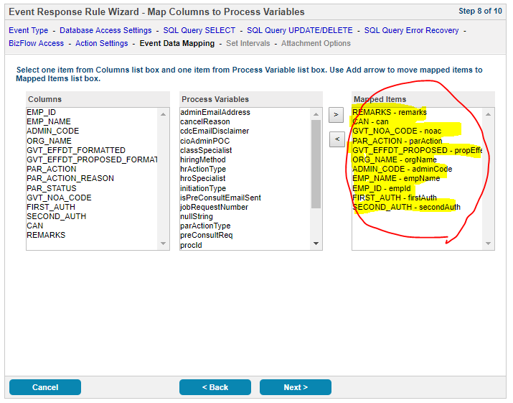

1. Set Intervals
   * Set Interval period: 1 hours
   * Check “No expiration date or time” in “Set event reponse expiration cirteria” radio button group.
   * Click “Next”



1. Attachment Options
   * Click “Finish”



Once you create the two ERA services, you can see the services in the Event Reponse page as below.

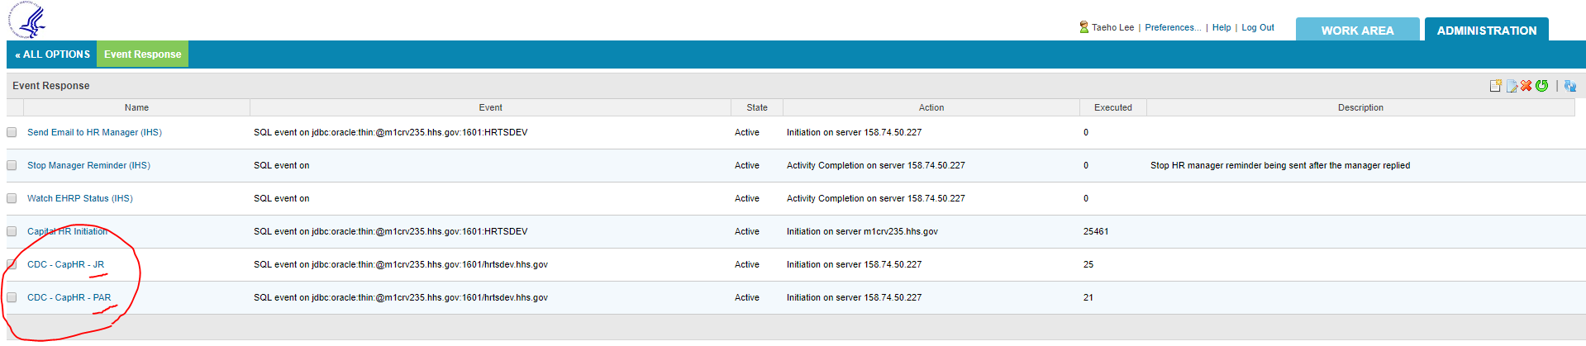

About Deloitte

Deloitte provides audit, tax, consulting, and financial advisory services to public and private clients spanning multiple industries. With a globally connected network of member firms in 140 countries, Deloitte brings world-class capabilities and deep local expertise to help clients succeed wherever they operate. Deloitte's 165,000 professionals are committed to becoming the standard of excellence.

Deloitte's professionals are unified by a collaborative culture that fosters integrity, outstanding value to markets and clients, commitment to each other, and strength from cultural diversity. They enjoy an environment of continuous learning, challenging experiences, and enriching career opportunities. Deloitte's professionals are dedicated to strengthening corporate responsibility, building public trust, and making a positive impact in their communities.

Deloitte refers to one or more of Deloitte Touche Tohmatsu, a Swiss Verein, and its network of member firms, each of which is a legally separate and independent entity. Please see www.deloitte.com/about for a detailed description of the legal structure of Deloitte Touche Tohmatsu and its member firms. Please see <http://www.deloitte.com/us/about> for a detailed description of the legal structure of Deloitte LLP and its subsidiaries.

Internal Usage Statement

This publication is for internal distribution and use only among personnel of Deloitte Touche Tohmatsu, its member firms, and its and their affiliates. Deloitte Touche Tohmatsu, its member firms, and its and their affiliates shall not be responsible for any loss whatsoever sustained by any person who relies on this publication.

Copyright © 2012 Deloitte Development LLC. All rights reserved.

Member of Deloitte Touche Tohmatsu